To access the Vacation Sale Portal, access the PGE@ Work For Me:
About Me My Time My Vacation Sale
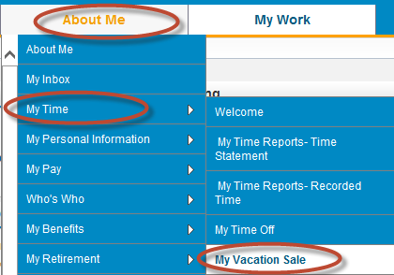
Pull the drop down arrow to select the name of the Vacation Sale Recipient you intend to donate too – be advised that more than 1 vacation sale may be open at a time.
Next to the name (s) of the vacation sale recipient are the dates in which that particular vacation sale is open
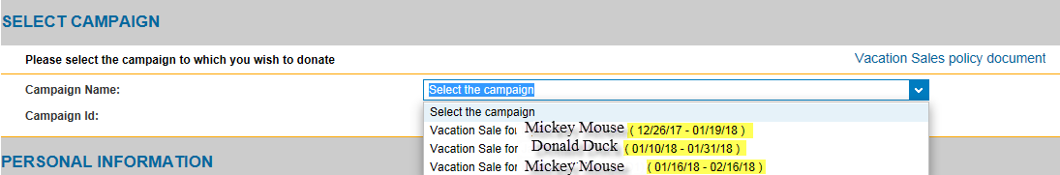

Your Personal Employee information should appear
Enter in the box the number of hours (in full hour increments) you wish to donate. The gross amount will be displayed
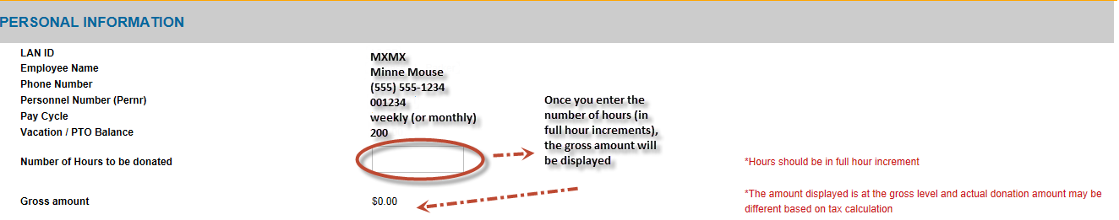

Make sure to check the box to authorize the vacation sale AND hit submit
